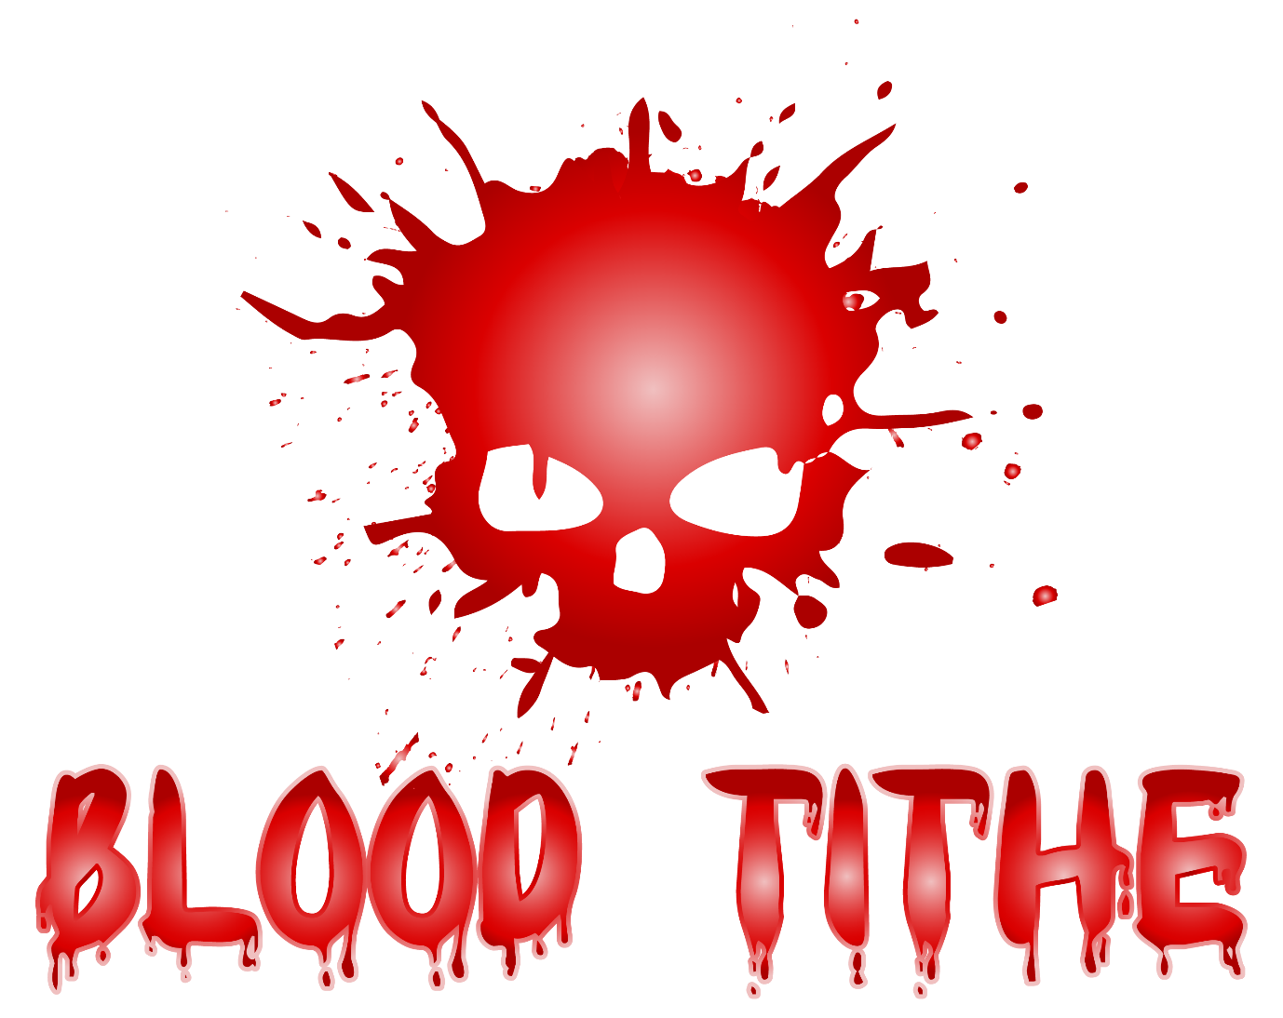
Age of Sigmar International Team Tournament
London Gatwick - Friday 2nd March to Sunday 4th March

In association with
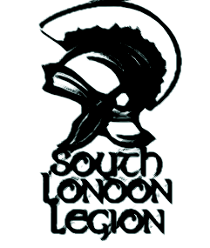

In association with The South London Legion I am delighted to announce the inaugural AoS International Team Tournament – Blood Tithe. The event will be staged at the Arora Hotel, London Gatwick – March 2-4th 2018. The event will be a 5 game, 2000 points, 4-man team, GHB2017 matched play tournament with additional gaming opportunities on Friday & Saturday night. We have space for 20 teams/80 players. The cost per team of 4, including a lunch on Saturday and Sunday is £180 (£45.00 PP).
Location
Gatwick/Crawley is 15 minutes from the M25, easily accessible by public transport from London, and not least the cheap short haul hub of Europe and beyond. Once arrived there will be very little extra travel to factor in. The hotel has direct access to Crawley train station via platform 2 – an 8 minute hop to Gatwick, or 35 minute trip to central London (Victoria)
Venue
The 4* Arora hotel is part of the Sofitel chain and has a dedicated conference space which we will use for gaming - complete with its own private bar. Crawley town centre, with myriad eating and drinking spots is a 2 minute walk away. Lunch will be provided by the hotel both days. The hotel has twin rooms from @£65 per night at time of writing. We have separated out accommodation from the ticket cost to leave it up to individual teams to decide where they stay – though obviously the weekend is geared towards staying in one place. The hotel website has comprehensive details about airport transfers: http://Gatwick.arorahotels.com
Please note hotel parking is £10 for 24 hours, there is however an alternative open air car park 100m away which is a much more reasonable £2.50 for 24 hours, and £1 all day on the Sunday (use postcode RH10 1SY).
The Arora Hotel Gatwick Crawley
Southgate Avenue
Crawley
West Sussex
RH10 6LW
Please be sure to book your hotel accommodation in good time to benefit from the best rates!

How to enter and key dates
A deposit of £60 per team, payable via Paypal friends and family to: marcjwilson@gmail.com - with the balance of £120 due by Oct 31st. Limited places are available for domestic teams. 50% of the places are reserved for International teams. These places will be held until 30th September where after they will be incrementally opened up to the general community. Please list your team name and captain and on the Paypal payment. Refunds can be given up until 1st Jan where after they can only be given should other teams fill the space.
The Tournament
This will be a 5 game, 4-man team tournament, using a “Swiss Pairings” method for determining opponents from Round 2 onwards. Pairings will be used. Lists will be publicised two weeks before the event. Where possible in the first round International Teams will be drawn against Domestic Teams, thereafter the draw will be open.
Schedule
Friday 2nd March
The gaming hall situated in the Longley Suite will be open for casual gaming from 2pm onwards. Registration will also be open from this point if you care to avoid a Saturday morning rush.
We will also run an organised Shadespire event on the Friday night. Please see the Shadespire Pack.
Saturday 3rd March
Registration (if not registered Friday): 0800-0900
Round 1 Pairings 0915-0930
Game 1: 0930-1200
Lunch: 1200-1300
Round 2 Pairings 1300-1315
Game 2: 1315-1545
Break / Round 3 Pairings 1545-1600
Game 3: 1600-1830
Saturday Night
The gaming hall will be open till 2300 for casual gaming. The private bar will also remain open until this time. Dependent on feedback and demand we may organise arranged activities - TBC
Sunday 4th March
Round 4 Pairings 0845-0900
Game 4: 0900-1130
Lunch 1130-1230 (Best Painted / Coolest Army display)
Round 5 Pairings 1230-1245
Game 5: 1245-1515
Awards: 1530-16.00
Event Closes: 1600
Please note that Sunday is slightly earlier and slightly more condensed – this is to allow for transport connections. 60, 30 & 15 minute countdowns will be announced. The dice down call will be strictly adhered to. If you reach 15 minutes to go and find yourself unlikely to finish please ensure you have equal turns. If you have any dietary requirements please let us know so that we can accommodate.
Army Selection
This will be a Single List 2000 points tournament and will follow all the restrictions in the General’s Handbook 2017 Matched play section – page 70 onwards.
Only Warscrolls with a points profile in The Generals Handbook 2017, current Battletomes up to and inc Feb 10th 2018, units with a Forgeworld points value or Compendium Warscrolls as per https://www.warhammer-community.com/2017/08/25/new-and-updated-faqs-forge-world-warscrolls-and-compendium-pdfsgw-homepage-post-1/ are valid.
Each player must play their own list for all games.
No two armies on the same team may have a duplicate warscroll, nor a duplicate allegiance. Units added via reserve points are not subject to these restrictions.
Allegiance abilities, Command traits and Artefacts must be listed on your Army List and not change on a game-by-game basis.
Firestorm supplement rules and abilities shall not be used.
List Submission and Draw
Lists must be submitted by 23.59 Sat Feb 17th.
Lists must be supplied as PDFs generated from Warscroll Builder on the Warhammer Community Website – please let us know if you encounter issues with your list.
The 1st round Draw will take place Monday 26th Feb, thereafter lists will be publicised.
Lists should be submitted collectively by the Team Captain to marcjwilson@gmail.com
Please remember to list your Allegiance abilities, Command traits and Artefacts – these must be stated on your army list.
Please bring 5 printed copies of you list for your opponents.

Battleplans
Battleplans will be played as stated in The Generals Handbook 2017 and be played in the following order.
Game 1 : Battle for the Pass (use Horizontal Set-Up as described in Starstrike)
Game 2 : Duality of Death
Game 3 : Total Conquest
Game 4 : Starstrike
Game 5 : Scorched Earth

Secret Missions
Each team will be presented with a deck of four custom Secret Mission cards. Each team will receive the same four Secret Mission cards. These must be divided up within the team before each game with each player receiving a maximum of two and minimum of zero cards. A new division of cards can be made before each game. Card holding players wishing to use them must reveal them to their opponents immediately after completing a Secret Mission. Allocation of cards can be decided upon immediately after pairings.
Secret Mission 1: Incalculable numbers
Destroy any three enemy Battleline units.
Secret Mission 2: Precision Strike
Destroy the enemy General and / or two enemy Leader warscrolls by the end of battleround two.
Secret Mission 3: Bring down the beast
Destroy an enemy Behemoth with a Battleline unit in the Combat Phase.
Secret Mission 4: Sustained Attack
Destroy any two enemy units during your own turn – either by killing them or causing them to flee to battleshock. You must reveal this card in the turn in which you attempt it, at the beginning of the hero phase, before any other actions are taken.

Scoring and Secret Missions
Major Win: 30
Minor Win: 20
Draw: 15
Minor Loss: 10
Major Loss: 5
Secret Mission 5 (per mission)
Individual player points will be capped at 30 points per round.
Total team points per round will be capped at 100/50.
Tie Breaker 1 – Uncapped TP total.
Tie Breaker 2 – Most Secret Missions TPs.
Tie Breaker 3 – Most Major Victories.
Please note in order to keep the advertised timings and to avoid overly punitive play Kill Points will not be recorded at all during the event and will be used only in missions where Kill Points are a deciding factor.

Under strength teams
We have a small pool of spare players – availability is not guaranteed however.
In the event of teams losing a player scoring will be weighted thus:
If the lack of player is the fault of the team, i.e. too hungover, player quits without good reason etc then the team in question will only gain the sum of the three remaining scores. The opposing team(s) will have the sum of their three scores increased by x 1.33.
If the lack of player is not preventable , i.e. illness, family emergency etc then both teams will have the sum of their three scores increased by x 1.33.
Pairings
Each team will be given four cards marked on the reverse with one of with their four armies. For ease of argument the Team ranked in an odd position will always be Team A, a Team ranked in an even position will always be Team B
e.g.
Team A - Chaos, Blades of Khorne, Stormcast, Destruction
Team B - Death, Order, Fyreslayers, Sylvaneth
Team A chooses to put forward Chaos (presented face down)
Team B chooses to put forward Order (presented face down)
Selections are revealed
Team A chooses to put down Blades of Khorne and Stormcast as options to play against the Order (presented face down)
Team B chooses to put down Death and Sylvaneth as options to play against Chaos (presented face down)
Choices revealed
Team A chooses between Death and Sylvaneth as to who Chaos will face, let’s say Death.
Team B chooses between Blades of Khorne and Stormcast as to who Order will face; let’s say Blades of Khorne.
Choices are revealed
The choice Team A refused faces the remaining card in Team B’s hand - Destruction
The choice Team B refused faces the remaining army in Team A’s hand – Fyreslayers
Resulting in:
Chaos v Death
Order v Blades of Khorne
Sylvaneth v Destruction
Fyreslayers v Stormcast

Painting
All armies must be fully painted and based on suitable round bases. Models on square bases are allowed, provided they are mounted upon suitable round/oval bases. Anything not reaching this minimum standard will, at the organisers discretion, be removed from the table, and will count as destroyed. There is quite a long lead up to the tournament so there’s no real excuse not to conform to this norm. The organisers will request a selection of armies be set up on Sunday Lunchtime for voting. You will be advised if you are on the shortlist. Armies will be voted by a guest judge.
The minimum requirement is 3 colours in an appropriate scheme, with no undercoat or bare plastic showing through with appropriate round/oval textured/painted bases.
All unit options and command models must be shown on the models, for example if the models in a Free Peoples unit have Swords you cannot use the rules for Halberds.
Terrain
Terrain will be provided on each table. The Scenery Table will be in effect and as per the 4 page rules. You are welcome to bring your own terrain if it adds to the aesthetic of your army and is not deemed to be outlandishly large or unsuitable.
You can purchase scenery dice from http://scenerydice.co.uk/ or alternatively bring suitable markers or use the markers provided in the player pack.
Terrain will be laid out on tables in a standard pattern, with no piece being with 6” of the table edge or another terrain piece.
If terrain has been moved around during the weekend and you can’t agree upon it’s placement, please see an organiser.
No terrain piece can be set up upon another – this includes Sylvaneth Wildwoods and Balewind Vortices.
You may remove trees (if they come out), but may not place or pass over models in the apertures created by tree removal.
Awards
Blood Tithe 2018 - Team Winners
Blood Tithe 2018 - Best Painted (Individual Prize)
Blood Tithe 2018 - Team Runners Up
Blood Tithe 2018 - Team Third Place
Blood Tithe 2018 - Best International Team
Blood Tithe 2018 - Best Sports
Sportsmanship and conduct
We expect this event to run as smoothly and controversy free as other AoS tournaments. Please remember than people may take different approaches to gaming to your group and all players will be expected to resolve rules disputes patiently and amicably. Please seek out an organiser if you cannot resolve a situation. Though we have private space allocated to us please remember to behave correctly around other patrons of the hotel in other areas.

Table etiquette
Take a few minutes before each game to run through your list and Warscrolls. You needn’t divulge your game-winning tactics but briefly summarise any abilities or battalions if required to. Be mindful of the timing of games with particular attention paid to getting through the turns equally with your opponent. We suggest Dice rolls should be flat on the game mat, not cocked, nor on terrain. Announcements will be made giving time remaining notifications. It’s advised to measure from the centre of objectives. You should have copies of Warscrolls in English to show to your opponent.
The trappings of success
What you will receive  A emailed PDF of all army lists ahead of the event  A score card to record results  Each team will receive four Secret Mission cards  Each team will receive four pairing cards  Scenery markers  Tables complete with pre measured terrain  Lunch on Saturday  Lunch on Sunday  … a great time we hope! | Remember to bring…  Five copies of your printed army list In English  A copy of the 4 page rules, any FAQs your require and printed or electronic copies of your Warscrolls.  Six Objective markers no bigger than 50mm in diameter  An ample supply of Dice  Wound Markers  5 copies of your Army list or a digital version  Glue (for any running repairs)  Pen and Paper
The final word…
Age of Sigmar tournaments are uncontroversial events in which friendly adults play toy soldiers against one another. Even though we have at points mentioned ‘..talk to an organiser’ we do not expect this to occur much, if at all, despite the introduction of ‘team’ and ‘international’ mechanics which are a little different to the norm.
FAQ’s / House Rules
- Measuring distances: All distances are measured using models bases as the reference point. This is known as measuring from ‘base to base’ When measuring distances vertically use the volume from the base foot print as high as the model’s head or torso, whichever is the highest point excluding limbs, wings, banners and weapons etc.
- Models unable to be attacked do not score until their current condition allows it, i.e. Changeling / Carrion ‘flying high’ etc.
Q: Does the Fyreslayers 'Warrior Kinband' 'Legacy of the Lodge' ability effect units or models?
A: Units
Q: Is the tunneling Fyreslayer Runesmiter and the tunnelling unit 1 drop/deployment?
A: Yes
Q: Does the Bloodstoker's 'Whipped to fury' effect both run and charge in the same turn?
A: Yes
Any official FAQs released on or before Feb 10th may supercede the above.

