Bendigo's Bush Bash Bonanza 2018

Thank you for checking out the players pack! In this document you will find all the details for this event. We would like to thank the various people/groups listed throughout for our shameless theft of certain things from your player packs. This is definitely something we are very keen to make happen and promise to provide our best efforts before, during and after the event, to ensure the best experience for everyone attending!
Cheers,
– The Measured Gaming crew.

When: 20th and 21st of October 2018

The Event:

Where: The Bendigo club – 22 park street, Bendigo, VIC Australia
Cap: 50
Cost: $50
Registration opens: now
Payments due: Sunday the 7th October Lists due: Sunday the 14th October
Contact: measuredgaming@hotmail.com

Schedule:

Rounds will last for 2.5 hours.

Day one:

8.30am – 9.00am Registration 9.00am – 11.45am Game 1 11.45am - 12.30pm Lunch 12.30pm -3.00pm Game 2 3.15pm – 5.45 pm Game 3

Day two:
8.30am – 9.00am Registration 9.00am - 11.45am Game 4 11.45am - 12.30pm Lunch 12.30pm – 12.45pm Paint Voting 12.45pm - 3.15pm Game 5
3.15pm - 3.30pm Pack-up and Tallying 3.30pm –4.00pm Presentations

Army Details/restrictions:

Composition:

Army size: 2,000 points per player
Players are to make their rosters using Matched play restrictions from the Generals Handbook 2018.
Compendium warscrolls and Forgeworld warscrolls are allowed in this event providing the most up- to-date warscroll and points are used.
Command traits, artefacts and all spells are to be noted on your roster.
Malign Sorcery will be used.
Firestorm will not be used.

Army list Submission/How To Pay:
Lists are to be submitted to measuredgaming@hotmail.com by 11:59PM on the 17th October 2018

Lists are to be submitted in plain text in the email. This is to ensure lists are easily readable and also helps when the lists will be released for public viewing. Please do not send screenshots from the Azyr app.
If a list is incorrectly submitted, you will be asked to resubmit and may incur a penalty on your score.
Payments are to be made via bank transfer to the details below. Please put your name and AoS in the transfer description. For example: ‘Steve S AoS’
Name: Measured Gaming
BSB: 013 - 533
ACC#: 213702663

Models, Basing and Painting:

Models:
Models are to be strictly WYSIWYG. Conversions, scratch builds and 3rd party models are allowed providing they accurately represent what they are meant to count as.
If you have a heavily modified or unusual model, please send a picture to the TO for approval.

Painting:

Models are to be painted to a 3 colour minimum. This does not mean paint 2 dots over an undercoat. Some reasonable form of effort has to be shown.
Models do not have to be painted certain colours to use certain models and/or rules. Such as Neave Blacktalon’s warscroll or Kharadron overlords sky ports as examples.

Unpainted models will be removed from the table

25 points will be up for grabs for painting. Most people will be able to achieve 15-20 points with 3 colour minimum.

Basing:

All models are to be based on rounds/ovals with no exceptions.

Scoring:

Painting and army list points Total 35TP
List submitted on time 5TP
List submitted in correct format 5TP
Army is painted to minimum standard 15TP Army is painted to higher standard up to 25TP

Gaming and battle points Total 100TP
Available points per game 20TP
Major Victory 20TP
Minor Victory 15TP
Draw 10TP
Minor Loss 5TP
Major Loss 0 TP

Sports points per game up to 5TP

Total 160TP

Gaming:

Games will be scored from a total of 20 gaming points up for grabs across both players, with a Major Victory being worth 20 points and so forth.
During the tournament, players will need to note on their score card how many points you scored in game for the scenario. These will be used as any tie breakers for final standings. Tertiary tie breaking will be enemy units killed, measured in points. You will be required to mark these down too.

What to bring:

Below is a quick list of some things you should consider bringing to the Bush Bash Bonanza

- Your Army (obviously)
- Some form of access to your units warscrolls (phone, battletomes, cards etc.)
  - Generals Handbook 2018 & applicable FAQ’s
    - At least 2 copies of your army list
      - Dice and Tape measure
        - 6 Objective Markers
- Glue (for incidental breakages)
  - Deodorant

Sportsmanship:

Cheating or other forms or antisocial behaviour may result in you being asked to leave the event. For any rules disputes, consult the rules, generals handbook, FAQs before asking the TO for a ruling.
The TO’s ruling is final. Regardless if you agree or not. It is advised to move on with the game after a TO has made a decision.
If you do have a disagreement with your opponent, it is advised not to judge their sports based on that. It should be based on how it was resolved.

Prizes:

First, Second and Third
Awarded to the three players who have the highest tournament points accumulated. Tie breakers:
- The first tie breaker will be based on the amount of in game points the players have scored over the 5 rounds.
- The second tie breaker will be enemy units fully slain. These will be calculated in the points of said units.

Best In Alliance
4 prizes up for grabs. Going to the players with the highest tournament points from order, death, chaos and destruction.

Best Opponent
Each player will be asked to nominate who their favourite (Primary), and second favourite (secondary) opponents were over the tournament. The winner will be the player who has the most primary votes. Tie breakers will be based on secondary votes.

Best Painted Army – TO’s Choice
Each player will be asked to set up their armies on the table they were playing on at the end of round one. The judges will inspect the armies over the lunch break. And will award the player who has the best painted army at the end of the event.

Coolest Army – Players Vote
The TO will create a short list of armies which they think are great. These shortlisted players will be asked to then set up their armies at the lunch break on day two. Each player will then have a chance to inspect those armies and vote on their favourite.

House Rules/FAQ’s and Clarifications:

FAQ’s up to the 1st of October 2018 will be used. Base to base measuring will be used.
Objective measuring is done from the centre of the objective.
Units with multiple musicians and banner options can only have one of each taken in a unit. Mysterious terrain should be rolled for before choosing sides.
Terrain warscrolls will not be used unless they are a part of your army (Sylvaneth wyldwoods etc)
If a wood of any kind has removable trees, feel free to remove them.
The holes in woods can be moved over normally without having to move up, down or around them.
True line of sight will be used.
The SCGT volume system will be in effect for measuring purposes
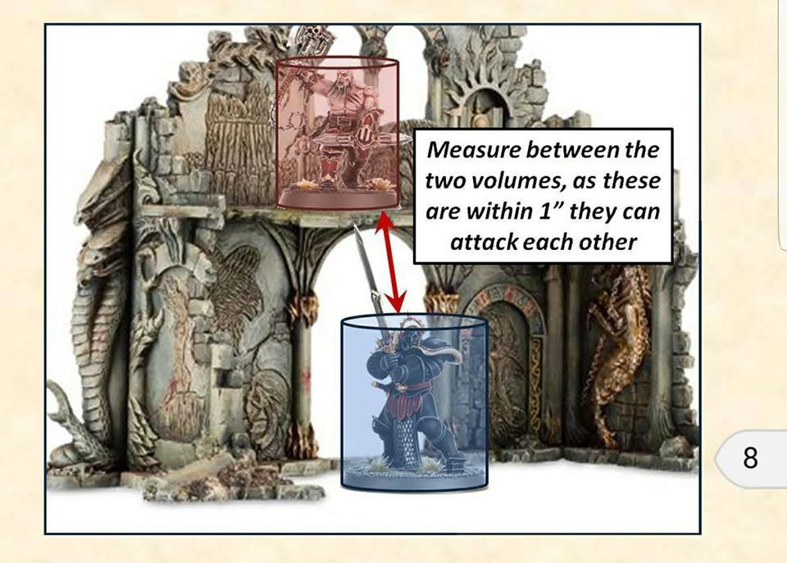

Realms and Malign Sorcery House Rules:

1. Battles will be taken place in the realm of Bogans. This realm has one rule. If you table your opponent by turn 3 it is customary to go to the bar and buy them a drink.

2. Picking a realm while writing a list will allow you access to the command ability(s), artefacts AND will unlock the spells for that particular realm.

3. All wizards in your army will know the realmsphere magic spell from your realm.

4. Wizards may pick ONE additional spell. from the realm lore OR your allegiances lore. Eg. A necromancer may know one spell from the LoN battletome, while another knows one spell from the shyish lore.

5. When submitting your army list, make sure to add in the realm spells you will be using. As these are house rules you will not be able to do it on warscroll builder.

There will be at least 8 pieces of terrain per table. These pieces of terrain will be in varying sizes, themed to the tables you will be playing on. The terrain will be pre setup before the event and should not be moved over the course of the event.
Players are not required to bring any terrain unless it is included with your display board.

Battleplans:

The Bash will be using 5 of the new battleplans from the Generals Handbook 2018. Given the nature of the event we decided not to add custom scenarios for this event.
The battleplans will be chosen prior to the event, but you will not find out which ones they are until the day.

Painting Rubric:

Criteria Points Achieved

Standard (max 20)

The army is entirely painted to a three colour minimum 15
Basic details of models are painted (i.e. gems, arrow tips, etc) 2
All models have consistent basing material/paint applied to all bases 1
When looking at the army it is visually cohesive 1
Army is on round bases 1

Optional (Max 10)
Painting Technique
Basic shading, highlighting or blending across whole army | 1
Or, Army displays advanced painting techniques (blending, NMM, OSL, etc) | 2
Freehand
Banners or some models display use of basic freehand or decals | 1
Or, Banners, flags and appropriate models are freehand painted to a high level | 2
Modelling
Some models are kitbashed or have minor conversions | 1
Or, Some models are extensively converted and dynamically posed | 2
Basing
Models have detailed basing | 2
Painted and based display board is used to present the army | 2

TOTAL (Max 25)

